# Instructions to book bus ticket to goa online to your grandpa.

redBus is India’s largest online bus ticketing platform that has transformed bus travel in the country by bringing ease and convenience to millions of Indians who travel using buses.

1. Click **Internet explorer** icon.
2. Go to address bar and type **redbus.in**.
3. Enter From and to address, select onward date and click the **Search buses** button.

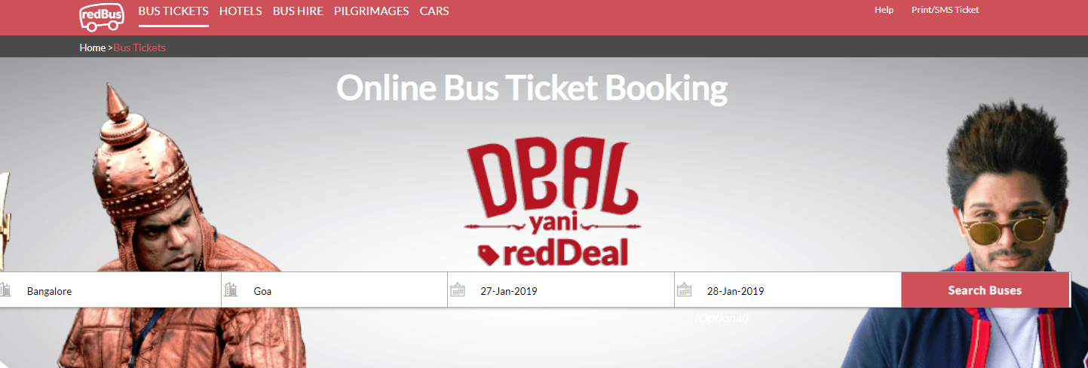

Figure 1

1. Select travels and click the **View Seats** button.

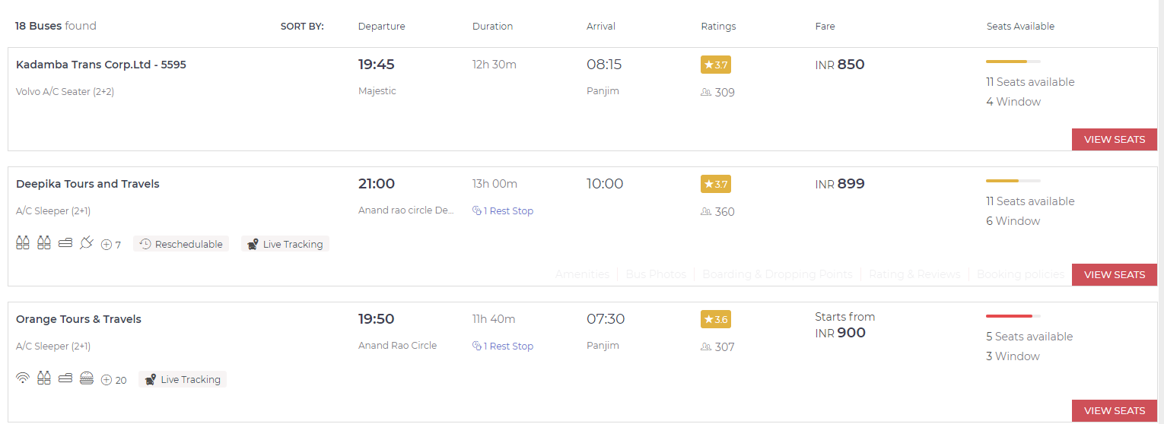

Figure

1. 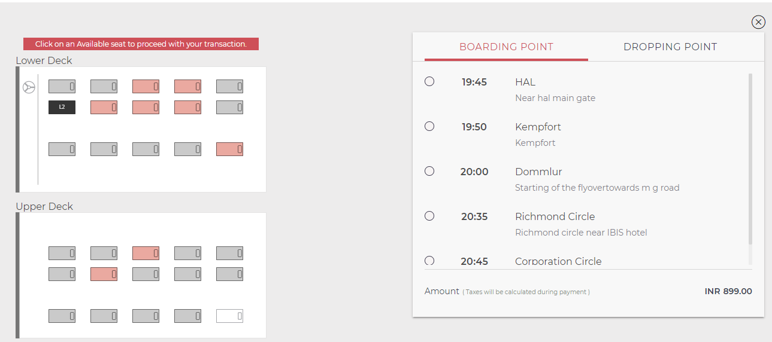Click the available seat and select the boarding and dropping point from the drop down.

Figure 3

1. Click the **proceed to book** button.

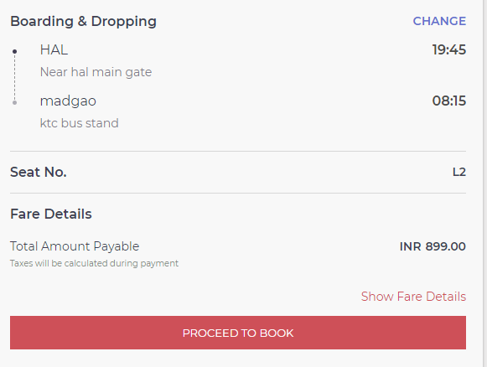

Figure 4

1. 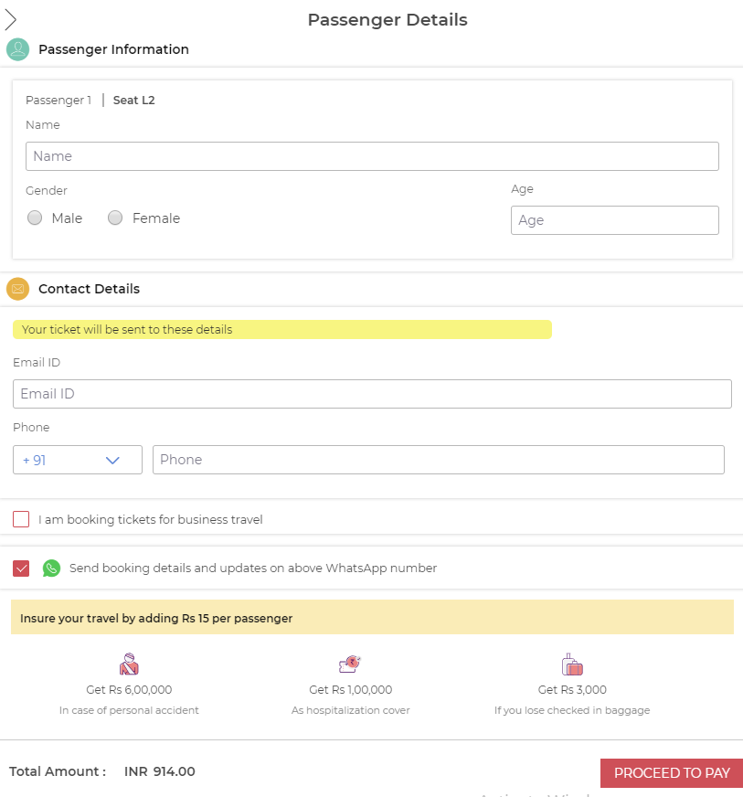Enter passenger information and contact details and click the **proceed to pay** button.

Figure 5

1. 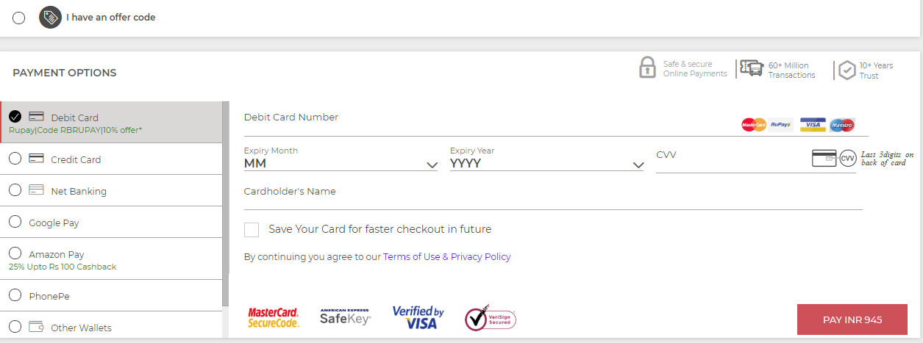From the list of payment options select the mode of payment and then click the **pay** button.

Figure 6

*Note:* Review travel details and fare break up before proceeding with the payment.

* After successful completion of your payment. A confirmation message displays on screen as “your ticket is confirmed”.

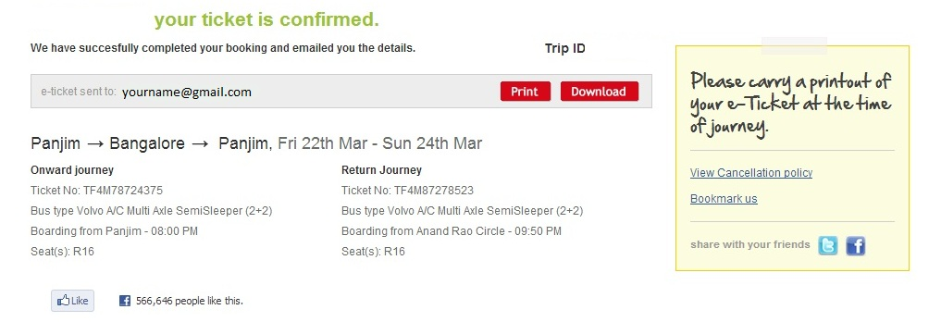

Figure 7